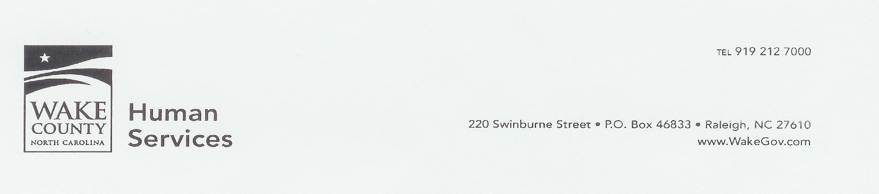

Wake County Transportation Complaint Policy

Was there a problem with your transportation?
For a commendation or a complaint to be filed, the customer must call the Wake County Transportation Call Center at (919) 212-7005 press option 4 or contact the Consumer Experience Team directly at 919-212-7155. Complaints may also be filed online: http://www.wakegov.com/humanservices/administration/Pages/HSComplaintForm.aspx
Complaints must be reported within 24-48 hrs after the incidence. The representative will enter the information into a database and distribute to the appropriate person. We appreciate any and all timely feedback, with as much detail as possible.
The WCTS staff will follow up with the appropriate persons to correct and resolve the issue. The customer will also receive a letter verifying that the complaint was filed and what the corrective measures are.
If dissatisfied with the resolution, then customers may appeal actions taken on complaint resolution within 7 days of the date of the resolution notification by addressing the Transportation Manager in writing at the address below. The appeal should include all relevant information
Wake County Human Services
Transportation Manager
220 Swinburne Street,
Raleigh, NC 27610

STEPS TO FILING COMPLAINTS
Client has 48 hours from the incident to file a formal complaint
Explain to the new complaint policy; you may transfer the call to the Consumer Experience Team at 919-212-7155

